|  |  |
| --- | --- |
|  | Year 12 Specialist  TEST 2  2018  TIME: 5 mins reading 40 minutes working Classpads **allowed!**  36 marks 8 Questions |

Name:_______________________________

Teacher: ____________________________

**Note: All part questions worth more than 2 marks require working to obtain full marks.**

Q1 (2 & 2 = 4 marks)

Consider .

1. Show that  is a factor of 
2. Determine three linear factors of 

Q2 (5 marks)

Consider  where  are constants. Given that  is a factor of  and when is divided by  has a remainder of . Determine .

Q3 (3 marks)

Given that  and . Does  exist over the natural domain of ? Explain your answer.

Q4 (2 & 2 = 4 marks)

Given that  and :

1. Determine the rule of 
2. State the natural domain and range of 

Q5 (3 & 3 = 6 marks)

1. On the diagram, sketch the inverse function 

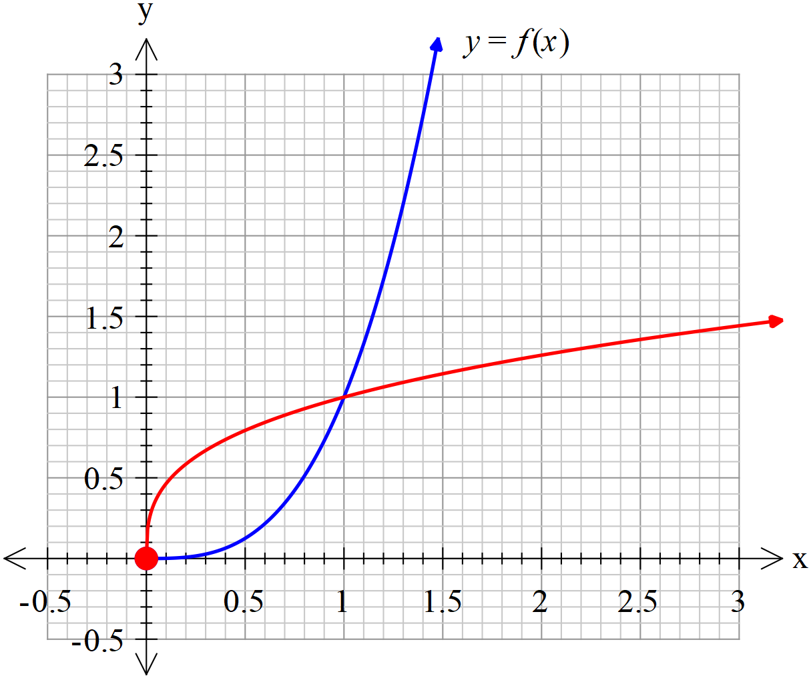

1. On the diagram below, sketch 

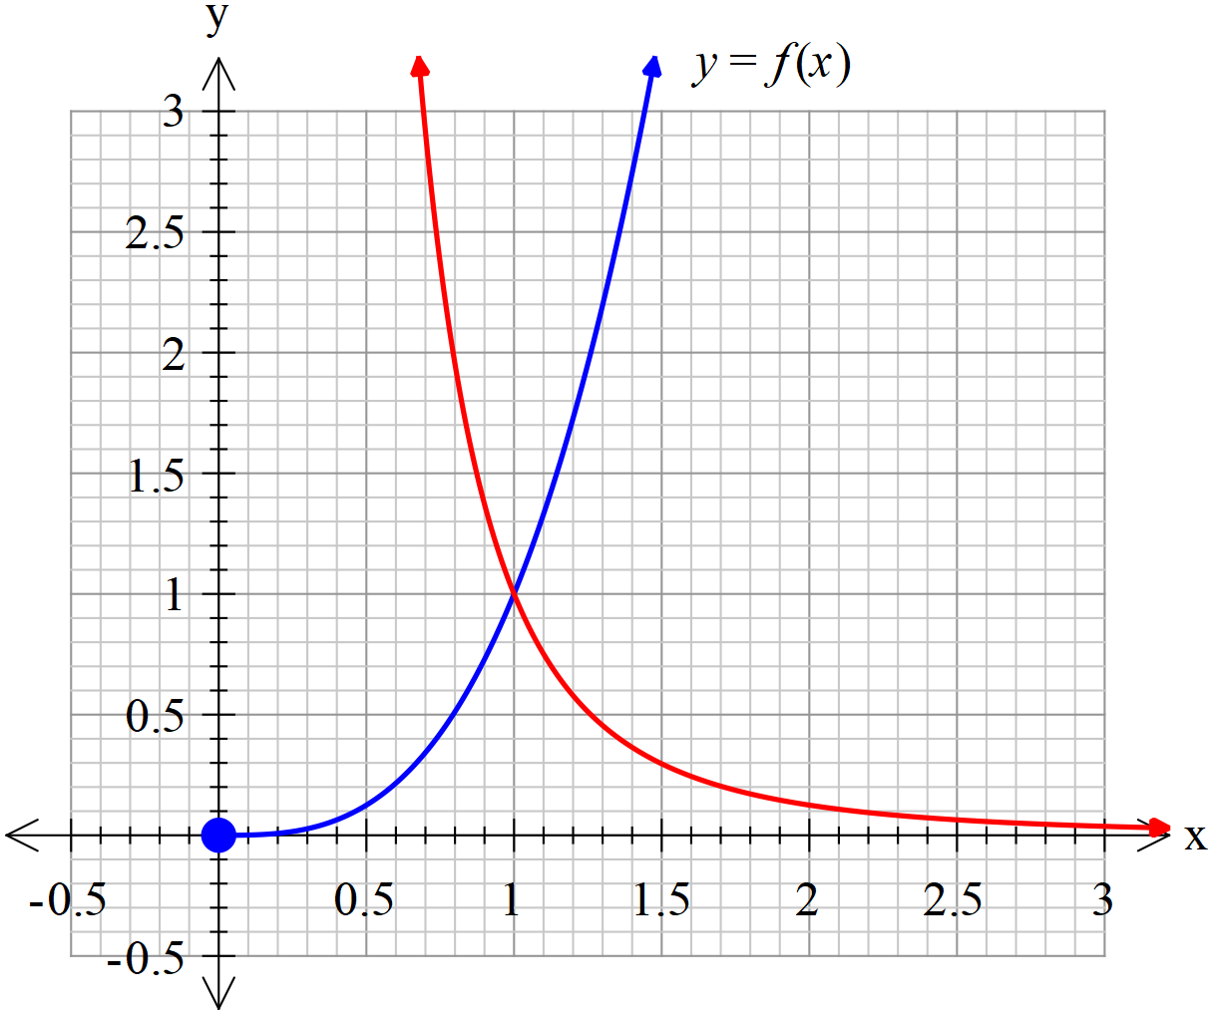

Q6) (1, 1, 2 & 2= 6 marks)

Consider the function  where  are non-zero constants.

1. Determine the natural domain of 
2. Determine the limit that  approaches as 
3. Determine the inverse function  in terms of .
4. Determine the possible values of  if  .

Q7 (4 marks)

Consider the equation  which is true and only true for .

Determine the possible values of the constants .

Q8 ( 4 marks)

Let  , prove that 